CSS Grid & Layout Complexity
A. THEORY
1. When would you choose CSS Grid over Flexbox? Give 3 specific scenarios where Grid is clearly the better tool.
When I need control over the 2 dimensions i.e rows and columns.
I. Dashboard layout
II. Photo gallery
III. Magazine websiite
2. Explain grid-template-areas and when it makes sense to use it over grid-template-columns.
grid-template-areas allows names to be given to different sections of a CSS Grid layout, such as "header", "sidebar", or "main", instead of placing items using row and column numbers. This makes the layout easier to read and understand because you can see the page structure directly in your CSS.
It makes sense to use grid-template-areas when building page layouts with clearly defined sections, such as a website header, navigation bar, content area, and footer. For simpler layouts where you only need to control column sizes, grid-template-columns is usually enough. Think of it this way: grid-template-columns controls how wide the columns are, while grid-template-areas controls where each section goes.

B. Engineering Thinking
1. Build a magazine layout: hero article spanning full width, 2 secondary articles side by side, 1 wide article at bottom, then 3 small articles in a row. Sketch it in ASCII art first, then show your Grid code. Explain your choice of fr vs auto vs percentages.

 | HERO ARTICLE
SECONDARY 1 |  | SECONDARY 2
 | WIDE ARTICLE
SMALL 1 | SMALL 2 |  | SMALL 3
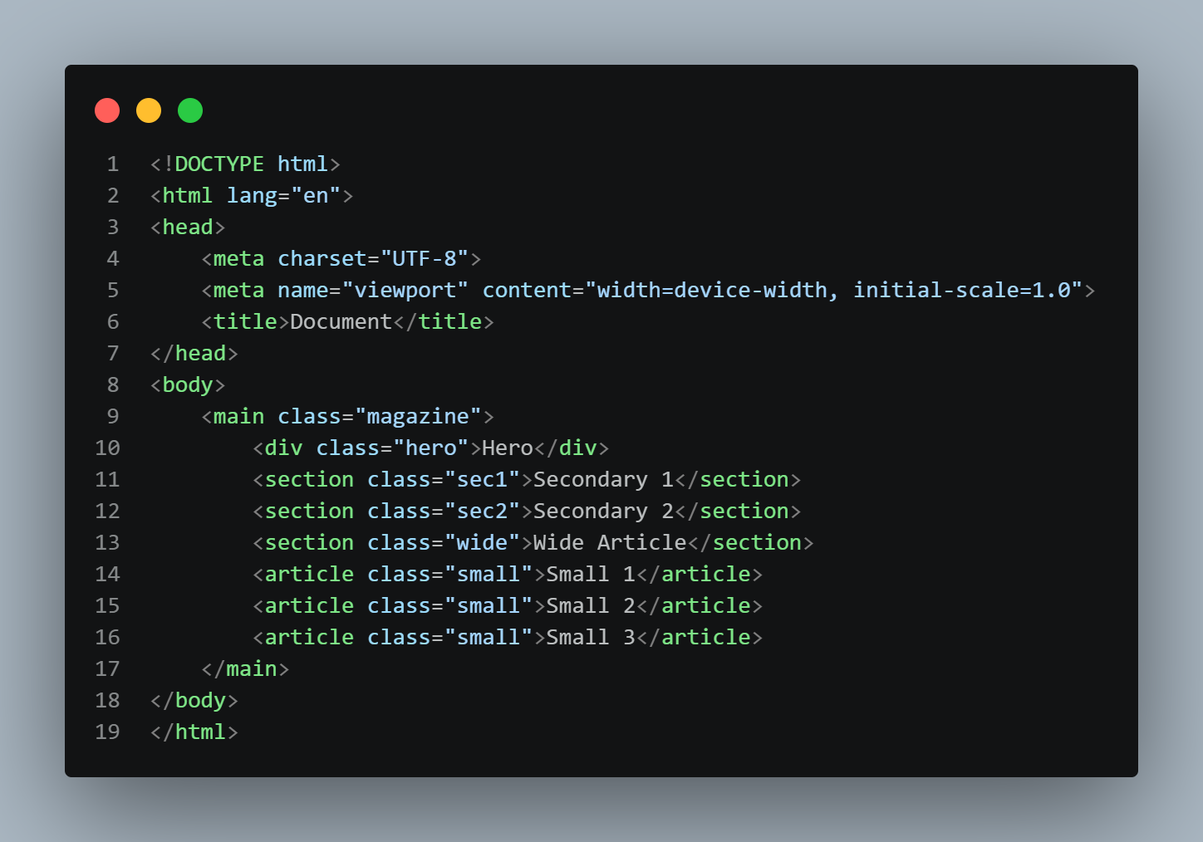
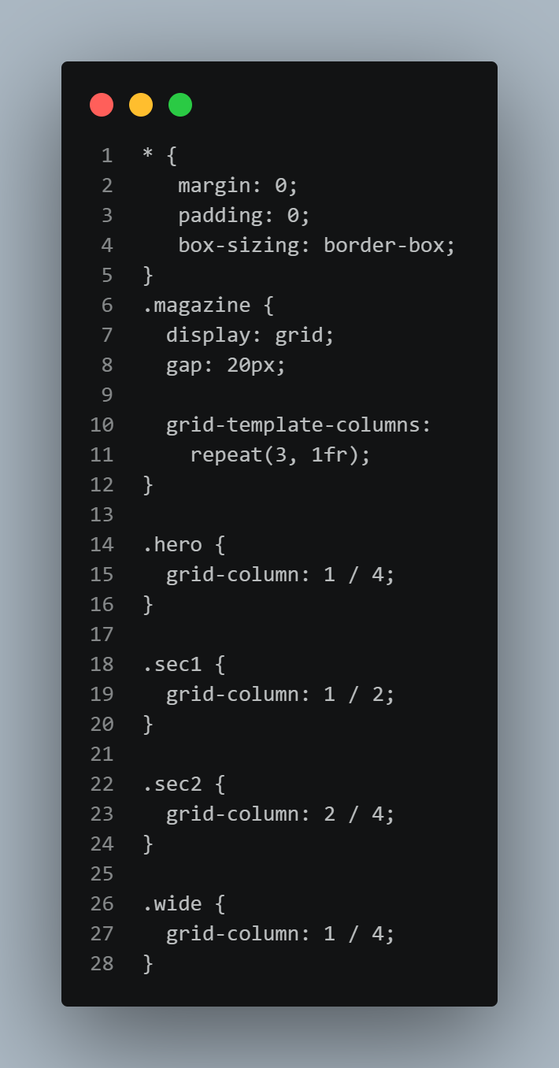
2. Build a responsive dashboard layout (sidebar + main content + right panel on large screens; sidebar collapses on mobile). Use only CSS Grid. No media queries — use only grid-template-columns with minmax() and auto-fit/auto-fill.
<!DOCTYPE html>
<html lang="en">
<head>
<meta charset="UTF-8">
<meta name="viewport" content="width=device-width, initial-scale=1.0">
<title>Document</title>
</head>
<body>
<div class="dashboard">
<aside>Sidebar</aside>
<main>Main Content</main>
<section>Right Panel</section>
</div>
</body>
</html>

.dashboard {
display: grid;
gap: 20px;

grid-template-columns:
repeat(
auto-fit,
minmax(250px, 1fr)
);
}

